Open Spaces Committee meeting
1st May 2024
Supporting Documents

Agenda item 6.2
A resident has requested to have a memorial bench on the cricket pitch. This is in memory of her son who passed away eight years ago. She would like to place the bench on/around what would have been his 30th birthday. The cricket pitch has been selected as she visits the area frequently and she is flexible on style/design.

Agenda item 6.4
Netball Club request at Recreation Ground
Local club request to hire out basketball court for netball once per week, non-peak times (Monday or Tuesday eve) at a rate of £25 per hour.
To facilitate this, netball lines would need to be painted on when the court is resprayed, and they would use the mobile netball hoops.
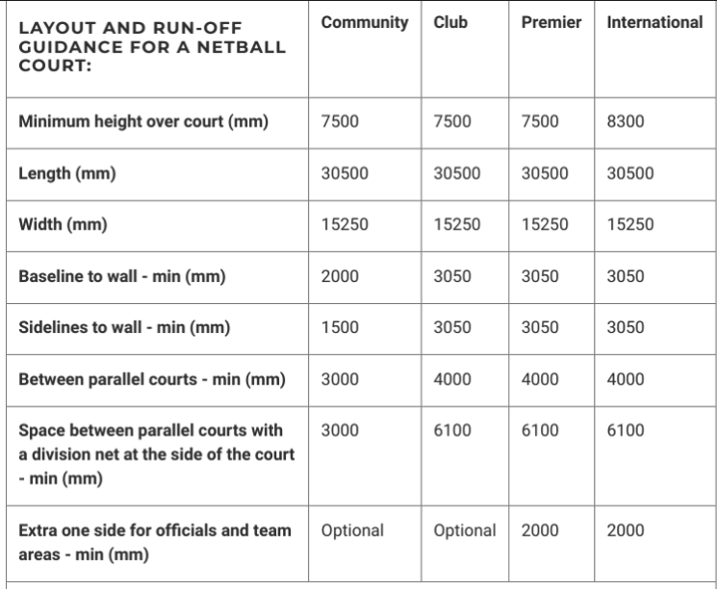

Agenda item 6.6
Further quotations being sought – will be updated following meetings on the 29th April. 2024.
Agenda item 9.1
Area update
Location | Action Required | Status | Notes
Badger Close | Boundary Encroachment  Badger Orchard  Pine Road Area | In progress  In progress | Clerk to research further.  Tree works booked.  Cllr Gebbett
Cemetery | Replacement gate stops.  Cemetery inspection | In progress | Planned in for Summer 2024
Lymington Bottom Green | Wildflower area and sign  Village sign remedial works.  New bench – FM Care. | In progress  On Hold. In progress | Signs delivered – to agree 2024 installation.  Awaiting site meeting date.
Oak Green parade | Flower bed maintenance  Book share.  Repainting of car parking spaces. | Ongoing  Agenda item  To do. | New contractor.  Book share delivered, awaiting painting and installation.  To review spacing and repainting – future meeting.
Recreation Ground | Cricket equipment  Containers  Skate Park  Tennis courts | Pending  Pending  In progress  In progress | Clerk to organise.  Grass mats to be installed  Area to be repainted.  Resurfacing in progress.
 | Football pitch/club  Footway along football pitch | Ongoing  In progress | Ongoing Liaison with Club regarding use.  Awaiting quotations.
 | Water refill point |  | Service completed March 2024. – contract expires October 2024; notice must be given July 2024 if contract is to be terminated.
Climate change mitigation | Solar Panels at Benians Pavilion | Pending | Awaiting information from Benians Committee Chairman following site visit
 | Nature boxes | Pending | Placed – awaiting EHDC promotional video.
 | Parish Trees | Completed | To review
 | Bus stop maintenance | In progress | Cllr Coulson – awaiting cleaning material delivery.
Swelling Hill Pond | Silt removal project | In progress | Awaiting further snagging.
 | South of pond/car park area. | In progress | Adverse possession claims in progress
 | Fencing replacement and small pond fencing. | Completed. | Quotations being sought
 | Car park remedial works. | In progress | Contractor accepted.
 | Tree works – overhanging pond. | To do.
Kingswood Copse | Ongoing maintenance for nature and wildlife. | In progress | Plan decided at meeting – Clerk to follow up.

